ME646 – Magnus Effect Experiment

April 26, 2017

Zhangxi ‘Jesse’ Feng, James Skinner, Simon Popecki

# Purpose

The goal of this experiment is to analyze the effects of cylinder diameter, rotational speed, and surface roughness on the lift force generated through the Magnus effect.

# Experiment Methods

D:\ME201617\ME Spring 2017\Final project\Final Project (Magnus Effect)\Plot.tifThe cylinders are made from aluminum and paperboard. Their diameters are, respectively, small diameter: 57.91 mm (2.28 in), medium diameter: 83.82 mm (3.3 in), and large diameter: 128.27 mm (5.05 in). The diameters were chosen to cover a sufficiently wide range in order to properly fit the effect of changing diameter on the Magnus lift force as shown in figure 1.

Figure 1 Airfoil radius versus Magnus lift force at 100 RPM

The cylinders are mounted onto endcaps. The left endcap is connected to a flange-bearing that is driven by a motor. The right endcap is connected to a plain bearing. The whole body rotates together while the hollow steel rod that supports the apparatus remains stationary. The steel rod is supported by the force balance on the side of the wind tunnel, which will also measure the lift force of the setup. The Solidworks model of the apparatus to be installed into the wind tunnel is shown in figure 2.

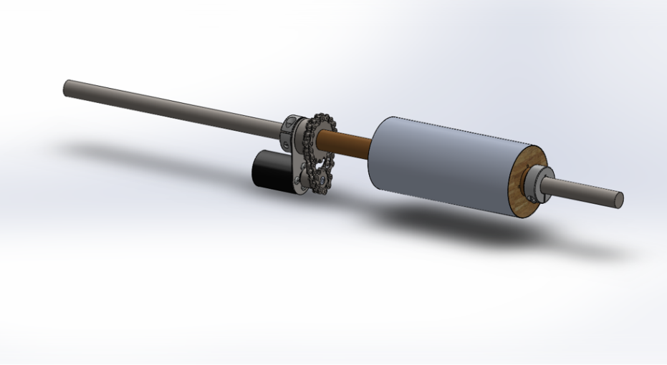

Figure 2 Solidworks Model of the apparatus on the steel supporting rod

The airfoil rotation speed versus expected lift force plots for the three cylinders are shown in figures 3 to 5 below.

Figure RPM vs. Lift Force for the smallest diameter Stella cylinder

Figure 4 RPM vs. Lift Force for the medium diameter Bud Heavy cylinder



Figure RPM vs. Lift Force for the largest diameter Quaker Oats cylinder

The Magnus effect lift force is given as:

$$F_{L}=ρvGL, G=2πr^{2}ω$$

Where $G$ is the vortex strength at RPM $ω$ for a cylinder of radius $r$, and the lift force is calculated using air density, $ρ$, wind speed, $v$, vortex strength $G$, and characteristic length of the cylindrical airfoil, $L=2r$. The formula suggests the force is linearly proportional to rotation speed, and follows a square relationship with the radius.

Assuming a constant wind speed of 20 m/s, the Stella cylinder’s small diameter means it requires a higher RPM to generate distinctly measurable forces. Therefore the three proposed RPMs are 580, 1160, and 1740 where lift forces of 1 N, 2 N, and 3 N are expected. The speed requirements for the larger diameter cylinders at the same force are reduced as shown.

To measure the effect of surface roughness, a sleeve of sand paper at grit sizes 20, 50, and 80 will be glued on the cylinders. The roughness ranges from very coarse to medium. The range falls short of fine as a fine sandpaper is not expected to affect the Magnus lift force significantly. It is possible to extrapolate the result to predict the surface roughness of the cylinders without sandpaper to check for the validity of the results.

When running the tests, measurements should be done after the system reached steady state after changing the RPM.